1. 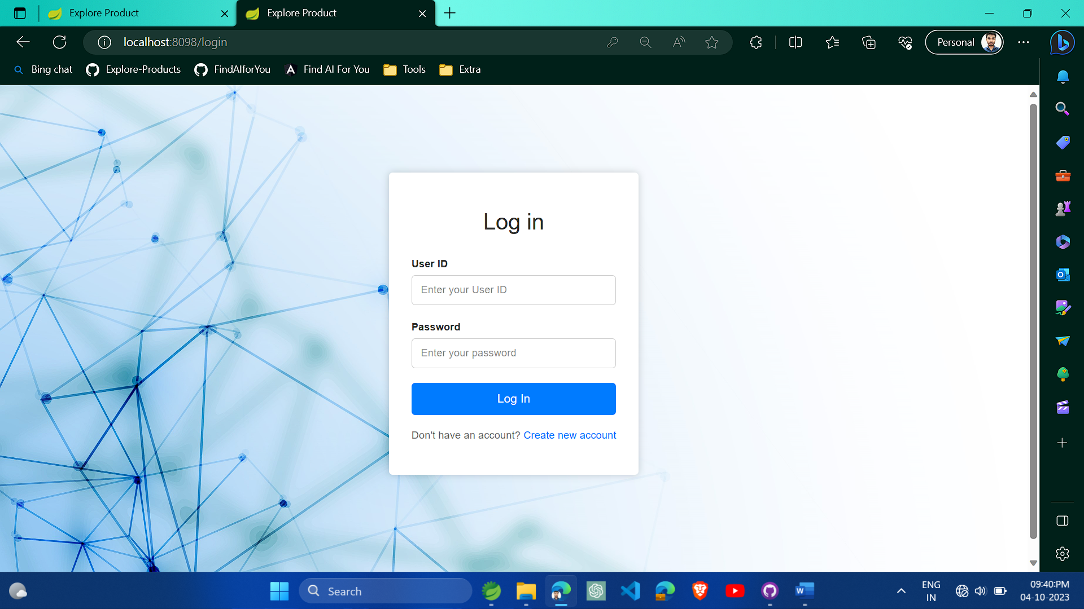Login Page
2. 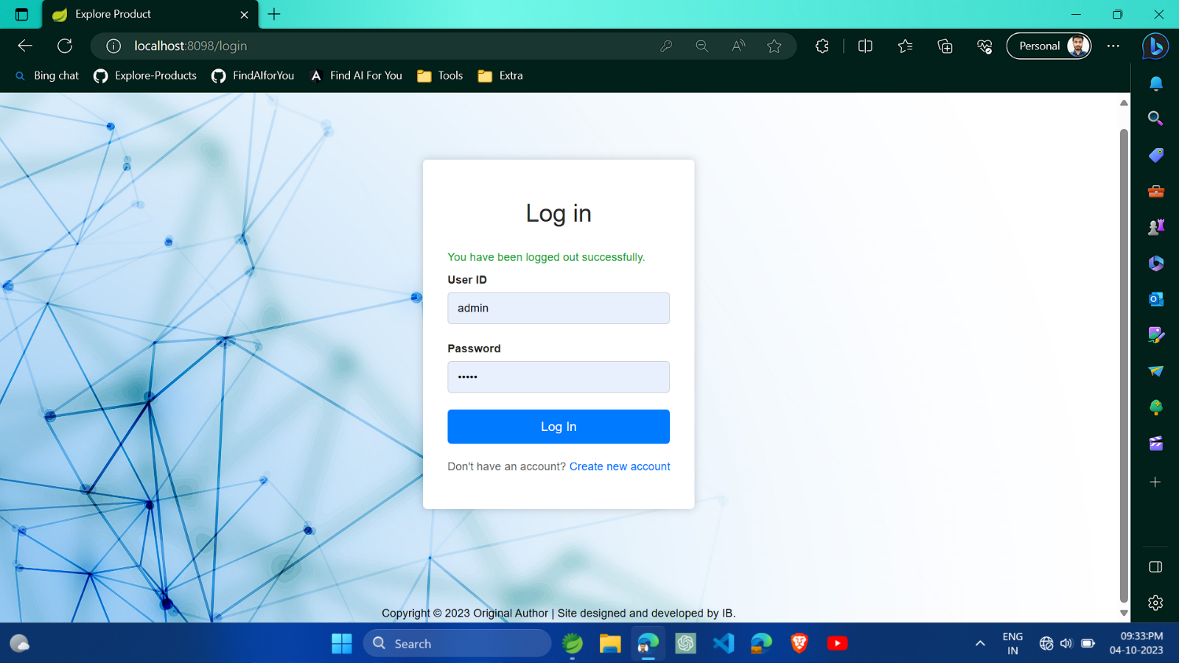Login Page after Log Out.
3. 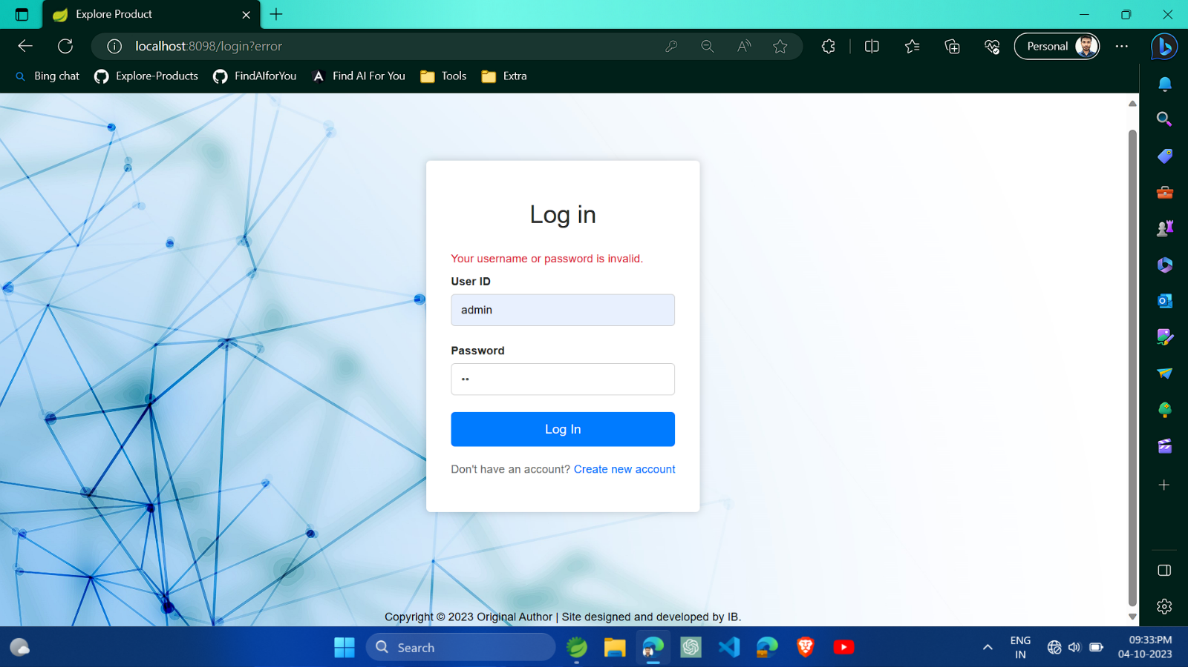Login Page In case of Invalid Username or password.
4. 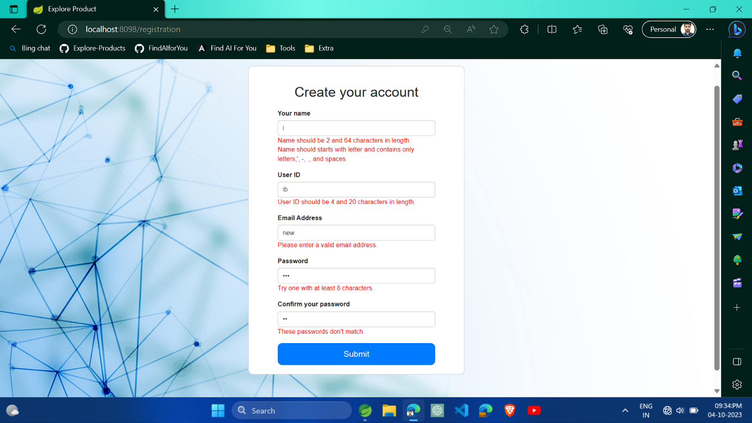New User registration page.
5. Home Page After successfully Login.

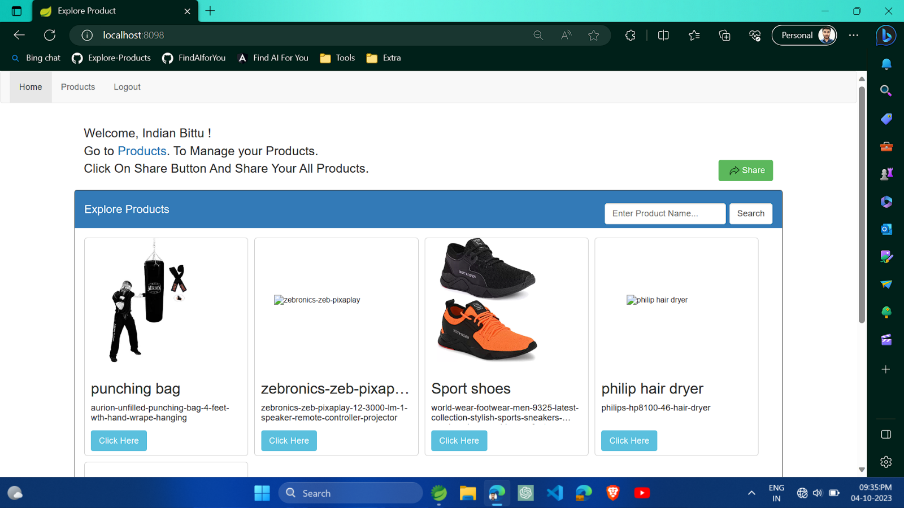

1. Product Page where user can update and delete product.

